Coastal Anesthesia, P.A.
PATIENT INFORMATION
Patient Name: ____________________________________________________________ Date: __________________________

Address (No PO Box): _________________________________________________ Birth Date: _____ /_____ /_____ Age: _____

City: __________________________________________________ State: ___________________ Zip:_____________________

Mailing Address (If Different): ______________________________________________________________________________

Gender: Male Female Marital Status: ___________________ SS # _________-_________-___________

Phone (First): ________________________ (Second): __________________________ (Third): __________________________

Ethnicity: Hispanic or Latino Not Hispanic or Latino Decline to provide this info

Primary Race: White Black or African American American Indian or Alaskan Native Asian Native Hawaiian or other Pacific Islander Hispanic Decline to provide this info

Email Address: _______________________________________ Driver’s License: ____________________________________

Employer Name: ____________________________________________ Occupation: __________________________________

Referring Physician: _____________________________________________________ Phone: ___________________________

Primary Care Physician: __________________________________________________ Phone: ___________________________

Pharmacy Name: _______________________________________________________ Phone: ___________________________

Primary Insurance  Insurance Name: _________________________________  Insurance Address: ________________________________  Insurance Phone # ________________________________  Group # ________________ Policy # ____________________  Insured’s ____________________ Relation: ______________  Name  Insured’s ____ /_____ / _____ Insured’s SS# ______________  Birth date  Insured’s Employer: __________________________________ | Secondary Insurance (if applicable)  Insurance Name: __________________________________  Insurance Address: ________________________________  Insurance Phone # ________________________________  Group # ________________ Policy # ____________________  Insured’s _____________________ Relation: _____________  Name  Insured’s ____ / ____ /____ Insured’s SS# ________________  Birth date  Insured’s Employer: _________________________________
Workers’ Compensation, Auto Billing Information (if applicable)

Insurance Carrier Name: __________________________________________________ Phone # ____________________________________

Address: __________________________________________________ Claim # ______________________ Date of Accident: ____________

Adjuster: _____________________________________________ Phone #_________________________ Fax # ________________________

Nurse Case Mgr: ______________________________________ Phone #_________________________ Fax # _________________________

Attorney: ____________________________________________ Phone #_________________________ Fax # ________________________

Are you taking any type of Blood Thinners or anti-coagulants? Yes No

If yes, which ones? Aspirin Plavix Coumadin Lovenox Other ___________________

Please list all medications you are currently taking including vitamins:

Medication Name Dose Frequency Currently taking?

________________________________ ____________ ____________________ Yes No
________________________________ ____________ ____________________ Yes No
________________________________ ____________ ____________________ Yes No
________________________________ ____________ ____________________ Yes No
________________________________ ____________ ____________________ Yes No
________________________________ ____________ ____________________ Yes No
________________________________ ____________ ____________________ Yes No
________________________________ ____________ ____________________ Yes No
________________________________ ____________ ____________________ Yes No
________________________________ ____________ ____________________ Yes No
________________________________ ____________ ____________________ Yes No
________________________________ ____________ ____________________ Yes No

Allergies Reaction No Known Drug Allergies

__________________________ ______________ ___________________________ __________________
__________________________ ______________ ___________________________ __________________
__________________________ ______________ ___________________________ __________________

Surgical History Date Surgical History Date

__________________________ _____________ __________________________ _______________
__________________________ _____________ __________________________ _______________
__________________________ _____________ __________________________ _______________
__________________________ _____________ __________________________ _______________
__________________________ _____________ __________________________ _______________

Social Activity
Do you currently use tobacco of any kind?  Never  Current Former
- If current: How much per day? ________ How many years? ________
- If former: When did you quit? ________ How many years? ________

Do you currently drink alcohol?  Yes  No Social
- Amount?: ___________  Beer  Liquor  Wine

Do you currently use any illicit drugs? Yes No what type? _________________________

Patient Name: _________________________________________

Please mark the diagram with the following:
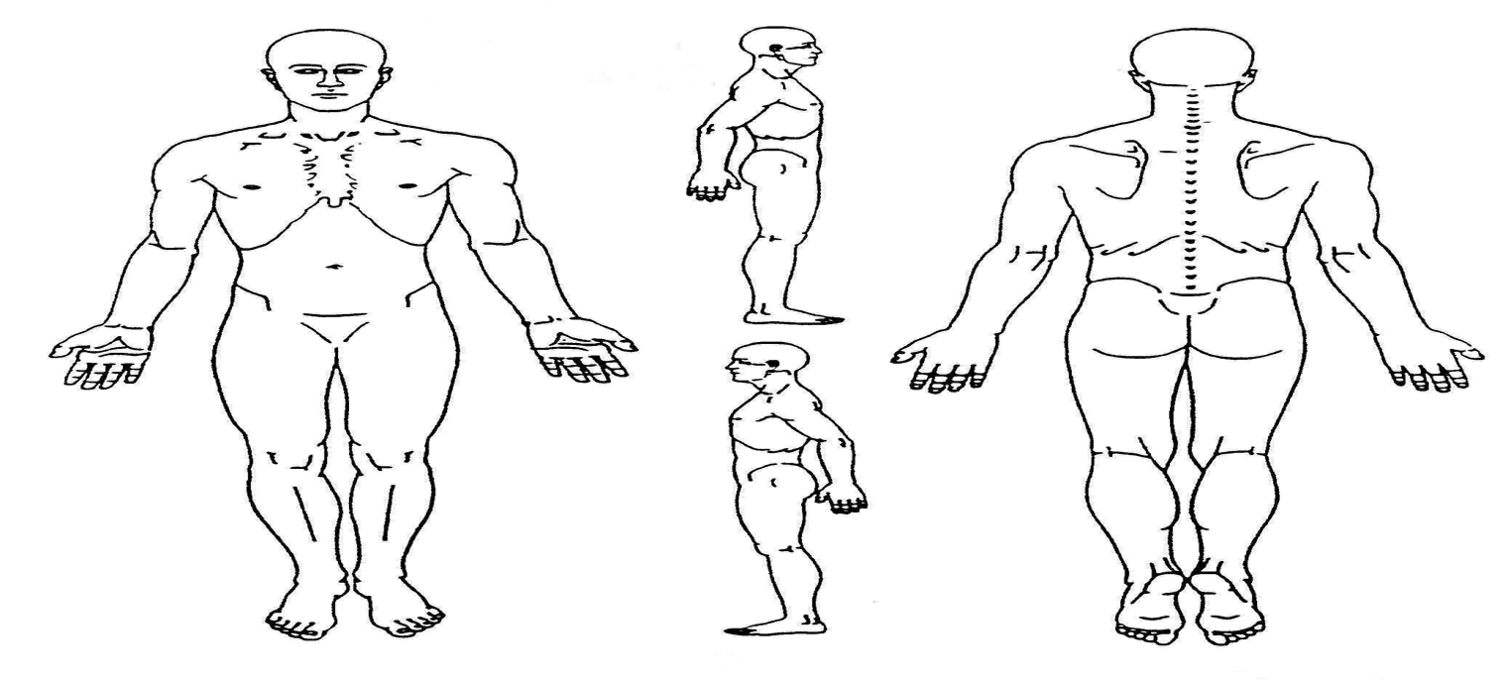
P = Pain
B = Burning
T = Tingling
N = Numbness
W = Weakness

Pain Scale (Circle the number that represents your current level of pain.)

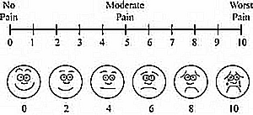

- When your pain is at its worst? __________________ When your pain is at its best? __________________
- How long have you been in pain? _____________________________________________________________
- Is your pain: Constant (100% of the time) Frequent (75%) Intermittent (50%) Occasional (25%)
- How would you describe your pain: Sharp Aching Burning Throbbing Shooting Indescribable Other: ___________________________________
- What worsens the pain? Standing Walking Sitting Activity Bending Twisting Lying Down Electric Bike Other:_____________________________________________________
- What relieves the pain? Medication Sitting Lying Down Standing Physical Therapy Chiropractic manipulation Heat Ice Other:______________________
- Does your pain affect any of the following: Concentration Activities of daily living Work Duties Physical activity Appetite Sleep Other:_____________________________
- Have you had any of the following problems recently:
Falls Dizziness Dropping things Restless Leg Syndrome
- Have you had any of the following procedures or treatments for your pain?

Facet Injections
Epidural Injections
Nerve Block
SI Joint Injections
Surgery w/ devices
Surgery w/o devices
Nerve Ablation (RFTA)
Medication
Psychotherapy
Massage Therapy
Acupuncture
Spinal Cord Stimulator

Physical Therapy (when, how long, where): _____________________________________________________
Chiropractic (when, how long, with whom): _____________________________________________________

Patient Name: ______________________________________

Coastal Anesthesia, P.A.
1001 W. College Blvd. Suite H
Niceville, FL 32578
Ph. 850-279-4417 Fax 850-279-4212

____________________________________________________________ ___________________________
Printed Patient Name Patient DOB

Please read and initial the following statements:

_____________ I hereby acknowledge receipt of Coastal Anesthesia P.A.’s Clinic Policy and Privacy Policy.

_____________ I have read and understand the Financial Policy and Authorization for Release of Information and agree to its terms.

_____________ I have read this disclosure and agree that Coastal Anesthesia, P.A., its employees and/or agents may contact me/us as described above.

By signing this form, you are acknowledging that you have been provided copies of the above office handouts.

____________________________________________________________________ _____________________________________ PATIENT/GUARANTOR’S SIGNATURE DATE SIGNED

____________________________________________________________________ _____________________________________
Relationship of Guarantor Witness's Signature
If the patient did not sign an acknowledgement of receipt Clinic Handouts, please list the reason the acknowledgement was not signed:
_______________________________________________________________________________________________
_______________________________________________________________________________________________

***********************************************************************************************

Consent to Release Confidential Information to Family Members/ Friends

I, ______________________________________________, give the physicians and office staff of Coastal Anesthesia P.A. permission to discuss my medical condition and/or account information with the following individual:

Name: __________________________________________________ DOB: _____________________________

Relationship: _____________________________________________ Phone: ___________________________

**This consent is in force indefinitely unless revoked in writing by the patient.

Patient Signature: __________________________________________________ Date: ________________________

Coastal Anesthesia P.A.

Pain Management Agreement

I understand that I have a right to comprehensive pain management. I wish to enter a treatment agreement to prevent possible chemical dependency. I understand that failure to follow any of these agreed statements might result in Dr. Ederer not providing ongoing care for me.

I, _____________________________________________________________, agree to undergo pain management by Dr. Ederer.

I agree to the following statements:

- I will not accept ANY narcotic prescriptions from another doctor.
- I will be responsible for making sure that I do not run out of my medications on weekend and holidays.
- I understand that Dr. Ederer will not supply additional refills for the prescriptions of medications that I may lose or are stolen.
- I will not give my prescriptions to anyone else.
- I will only use one pharmacy.
- I will keep my scheduled appointments with Dr. Ederer unless I give notice of cancellation 24 hours in advance.
- I agree to refrain from all mind/mood altering/ illicit/addicting drugs including marijuana or cocaine.
- I agree to routine urine drug screens and random pill counts.
- My treatment plan may change based on outcome of therapy, especially if pain medications are ineffective. Such medications will be discontinued. If a change is deemed necessary in my medication, I will be asked to return unused meds to the office for count and waste before a new prescription can be written.
- Dr. Ederer may terminate this agreement at any time if he has cause to believe that I am not complying with the terms of this agreement, or to believe that I have made a misrepresentation or false statement concerning my pain or compliance with the terms of this agreement.
- I understand that I may terminate this agreement at any time.
- If the agreement is terminated for any reason, I understand I will no longer be a patient of Dr. Ederer and would strongly consider treatment for chemical dependency if clinically indicated.

_____________________________________________________________ ________________________
Patient Signature Date

_____________________________________________________________ ________________________
Physician Signature Date

